

Connecting to XenDesktop VDI via ICA client from Internal XenApp Portal
- Login to XenDesktop Citrix Web Portal by clicking on https://ctrxna.wlb2.nam.nsroot.net
Note: Please use Internet Explorer and not Firefox or Chrome

- You will get the following screen. Change the Domain dropdown to the appropriate domain (NAM). Type your domain SOEID and password, and click on “Click to login”
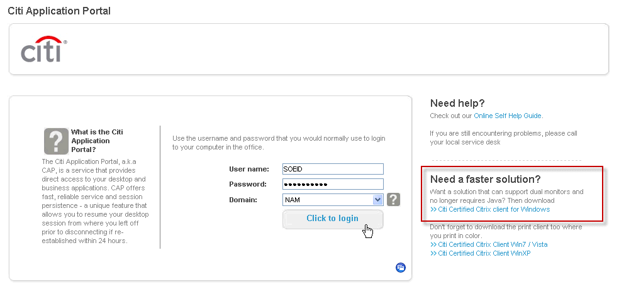
- Once you login, you will get the following screen. Click on “Cap Virtual Desktop”. (note that the available choices may differ as this depends on your computing profile, you may see “CAP Virtual Desktop-DR” and/or “CAP Virtual Desktop-COB”)
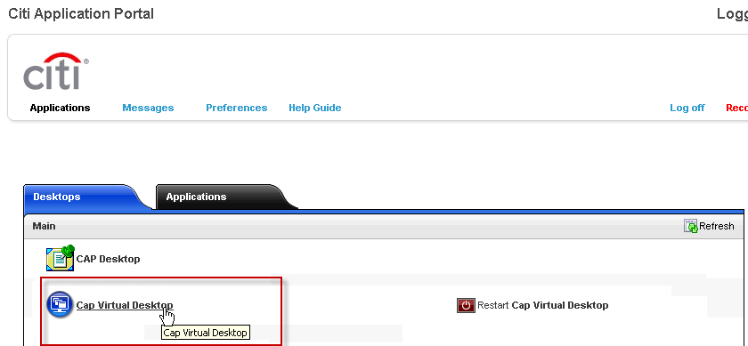
NOTE: You will have option to restart your VDI by clicking on “Restart CAP Virtual Desktop”.
- You’ll get the following window that says Connecting to your desktop. It’ll take a few seconds before it connects.
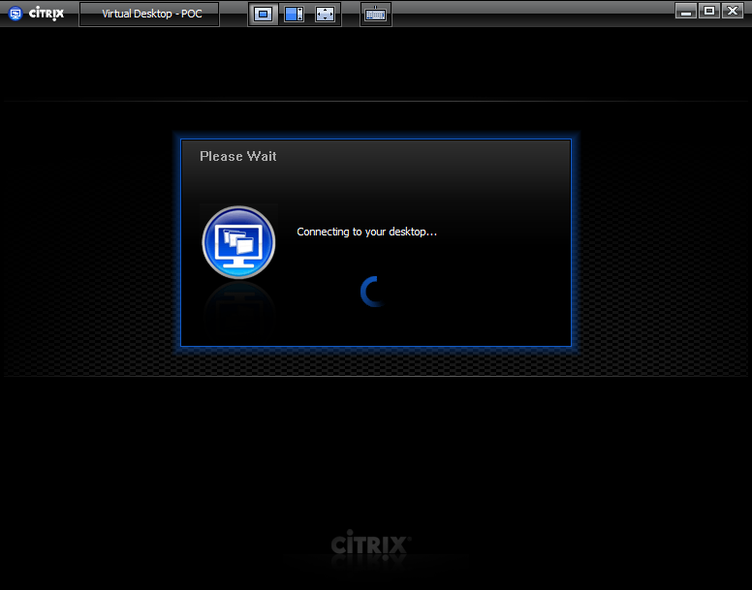

- Once it connects, you will see the Windows 7 or XP Desktop login prompt. Click OK and it will log you in as you normally would to the domain.
